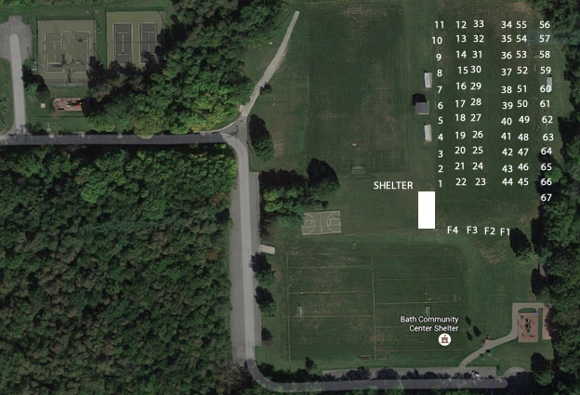

**Vendor**

**parking**

* 1000
* 

1v

PARKING

11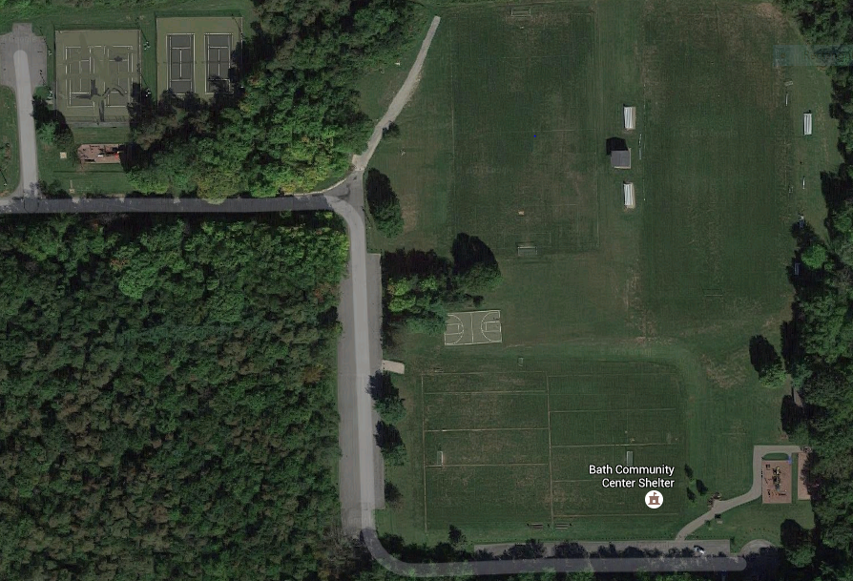

8

1. Incantations by Karyn
2. Kromara Candles
3. Pierce Jewelry
4. New Day Organics
5. New Day Organics
6. Darrell Kent Pointelism
7. ThistleDew
8. Visions & Vessels
9. Hira Jewelry
10. Laurie Anderson
11. Kevin Alten Designs
12. Sharon’s Creations
13. Sharon’s Creations
14. Ms. Cotti Biscotti
15. A Matter of Taste Pottery
16. Drew Hocevar Glass
17. Horseshoe Lake Studio
18. Great Lakes Spices
19. Images in Bloom
20. Jennifer Worden
21. Landford Bead Works
22. Renee Flynn
23. Barb Barbee Jewelry
24. Oh So Delicious
25. Joseph Dull
26. Kristin Ellis Jewelry Artist
27. Grace Art Studio
28. Lazer Etched Creations
29. Lazer Etched Creations
30. Jeanne Fashempour
31. Fine Art Findings
32. Thee Etching Glass
33. Thee Etching Glass
34. Swordfish Pottery & Glass
35. From Nature to You
36. Dippity and Snark
37. Swell and Cedar
38. Indigo Lake Sauce Co
39. Oddities In UpPsychling
40. Harvest Hills Skin Care
41. The Wood Guy
42. Mirrored K Studio
43. The Crafty Couple Ohio
44. Totally Tangled Creations
45. Darby N Woods
46. The BOM Parties
47. HandYwork by Yvonne
48. My Beverly Jewerly
49. Lily Lue Designs
50. MinusG
51. Wreaths By Tracey Anne
52. Moon Eyes Designs
53. Mr. Crisp Pickle Co.
54. Susie Lowder
55. Garden Glass by Anne
56. Nepali Artisans
57. Mc's Pics
58. Well Preserved Jams & Jellies
59. Uniquely Ashley Designs
60. Rainbow Joy by Marjorie
61. Glait Creations
62. Art x Love
63. Pane in the Glass
64. Kyle May Photo
65. Pine Haven Ceramics
66. Glassy Gals
67. Willow Cat Designs

F1 Café Arnone

F2 Henry’s Creamery

F3 Car Hops Mobile Diner

F4 The Urban Wrap

IN SHELTER  
Bath Business Association/ Bath Community Fund/BVS